Week 10 Tutorial – Security Culture & Personnel Security

Human and organizational factors in computer and information security are discussed in some detail in the article Human and organizational factors in computer and information security: Pathways to vulnerabilities by Sara Kraemer, Pascale Carayon and John Clem.

In Pairs

Question 1) Report Back on the IT Security Role
Search the internet (for example in trademe.co.nz or seek.co.nz) for IT jobs that include the word “security”. Choose a favourite in your pairs and summarise the type of security activities and tasks that you can find (select at least 5 different kinds of activities) included in the job descriptions.
Consider these tasks in relation to information security management frameworks and associate the tasks with a phase in the information security management framework:
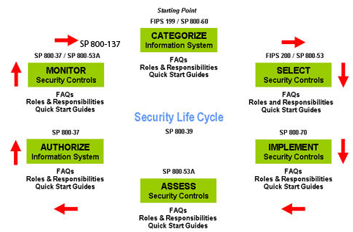

Review the IT Remuneration Report from Absolute IT and identify the salary range of IT Security personal: http://znze11wt5g3330m4e3it6h2a73.wpengine.netdna-cdn.com/wp-content/uploads/2014/12/Final-Remuneration-Report-Dec-2014-Absolute-ITv3.pdf

Individually or in pairs

Question 2)
Consider the following diagram presented in the lecture notes about the human aspects of security:

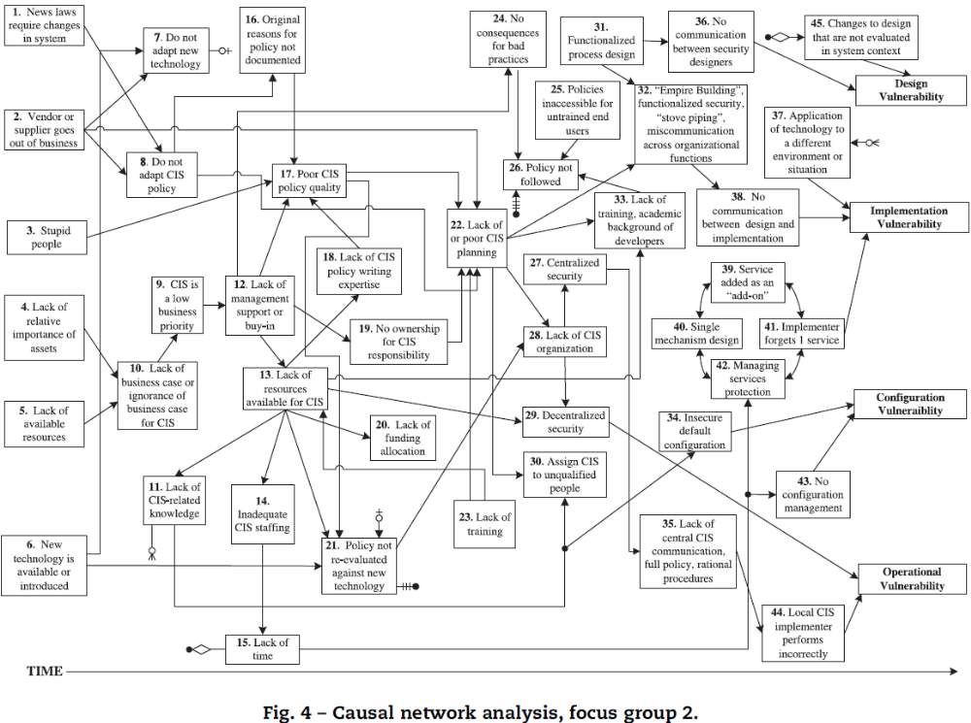

a) Select three aspects in the boxes in the diagram above: one from 1-11 range, one from 12-23 range and one from 24-45 range. These three aspects can appear on a pathway to a security vulnerability.
Consider the questions:
(i) Could these happen? Can you imagine a situation?
(ii) How might it be prevented?
(iii) How might your prevention lead to a different vulnerability?
b) Create a fresh pathway that is not presented in the diagram.

Download the Human and organizational factors in computer and information security article from AUT library to get more information about potential aspects:
https://networkservices.aut.ac.nz/ezproxy.cgi?url=http://www.sciencedirect.com/science/article/pii/S0167404809000467

Question 3)
Select a practical security measure, such as content filtering of emails and web-site traffic (spying on) in the workplace.
a) Create a table and write a 3 paragraph discussion on the pros and cons of your chosen practical security measure, focusing on the ethical, cultural and organisational implications.
Review the principles on pages 10-12 of the OECD guidelines for the Security of Information Systems and Networks as a starting point for your considerations. You can find this article at:
http://www.oecd.org/document/42/0,3746,en_2649_34223_15582250_1_1_1_1,00.html

b) Consider the following question:
(i) Who would be likely administrator of the security measure?
(ii) Would this work give the person access to sensitive information they did not have previously?
(iii) Is the security measure worth implementing despite the new risk?
(iv) Why would staff like / or not like the solution (would it limit their freedoms, expose their personal data...)?
(v) How would you convince everyone about the benefits of this new tool?

